Report for Lab-Assignment7

1.

Question:

Sentimental analysis using twitter streaming

Description:

We have collected the tweet data for our project and performs Sentimental analysis by using that data. The output is in the form like positive or negative as we have given the cases like from 0-very negative to 5-very positive. There is elaborate explanation in Screenshots.

Screenshots:

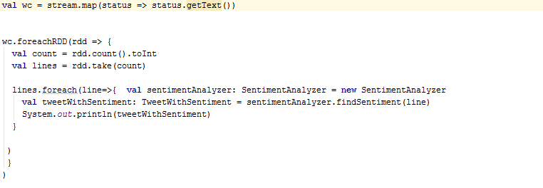

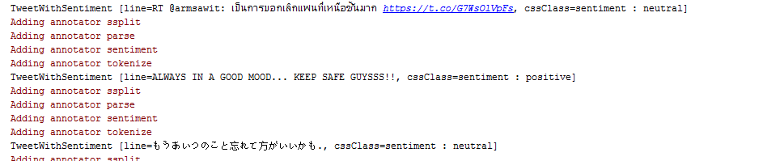

2

Question:

3

Question:

Twitter trend notification to smartphone / smartwatch

Description:

We have sent the Twitter Trend Notification Using the Sentimental Analysis from the Question-1.

Screenshot:

